Name : Vedant Sanjay Dhamale

Roll No : 2337032

Problem Statement : Socket Programming using C/C++/Java. a. TCP Client, TCP Server b. UDP Client, UDP Server.

**TCP Client code:**

import java.net.*;

import java.io.*;

class MyClient{

public static void main(String args[])throws Exception{

Socket s=new Socket("localhost",3333);

DataInputStream din=new DataInputStream(s.getInputStream());

DataOutputStream dout=new DataOutputStream(s.getOutputStream());

BufferedReader br=new BufferedReader(new InputStreamReader(System.in));

String str="",str2="";

while(!str.equals("stop")){

str=br.readLine();

dout.writeUTF(str);

dout.flush();

str2=din.readUTF();

System.out.println("Server says: "+str2);

}

dout.close();

s.close();

}

}

**TCP Server code:**

import java.net.*;

import java.io.*;

class MyServer{

public static void main(String args[])throws Exception{

ServerSocket ss=new ServerSocket(3333);

Socket s=ss.accept();

DataInputStream din=new DataInputStream(s.getInputStream());

DataOutputStream dout=new DataOutputStream(s.getOutputStream());

BufferedReader br=new BufferedReader(new InputStreamReader(System.in));

String str="",str2="";

while(!str.equals("stop")){

str=din.readUTF();

System.out.println("client says: "+str);

str2=br.readLine();

dout.writeUTF(str2);

dout.flush();

}

din.close();

s.close();

ss.close();

}

}

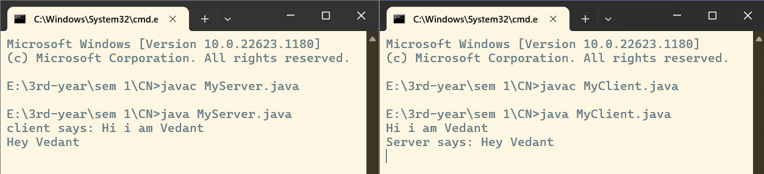Output:

**UDP Server :**

import java.net.*;

import java.io.*;

public class UDPServer {

public static void main(String[] args) {

try (DatagramSocket serverSocket = new DatagramSocket(9876)) {

while (true) {

byte[] receiveData = new byte[1024];

DatagramPacket receivePacket = new DatagramPacket(receiveData, receiveData.length);

serverSocket.receive(receivePacket);

InetAddress clientAddress = receivePacket.getAddress();

int clientPort = receivePacket.getPort();

String clientMessage = new String(receivePacket.getData(), 0, receivePacket.getLength());

System.out.println("Received from " + clientAddress + ":" + clientPort + ": " + clientMessage);

// Read a response message from the server console

BufferedReader br = new BufferedReader(new InputStreamReader(System.in));

System.out.print("Enter a response for the client: ");

String serverResponse = br.readLine();

byte[] sendData = serverResponse.getBytes();

DatagramPacket sendPacket = new DatagramPacket(sendData, sendData.length, clientAddress, clientPort);

serverSocket.send(sendPacket);

}

} catch (IOException e) {

e.printStackTrace();

}

}

}

UDP Client :

import java.net.*;

import java.io.*;

public class UDPClient {

public static void main(String[] args) {

try (DatagramSocket clientSocket = new DatagramSocket()) {

InetAddress serverAddress = InetAddress.getByName("localhost");

int serverPort = 9876;

while (true) {

// Read a message from the client console

BufferedReader br = new BufferedReader(new InputStreamReader(System.in));

System.out.print("Enter a message for the server: ");

String clientMessage = br.readLine();

byte[] sendData = clientMessage.getBytes();

DatagramPacket sendPacket = new DatagramPacket(sendData, sendData.length, serverAddress, serverPort);

clientSocket.send(sendPacket);

byte[] receiveData = new byte[1024];

DatagramPacket receivePacket = new DatagramPacket(receiveData, receiveData.length);

clientSocket.receive(receivePacket);

String serverResponse = new String(receivePacket.getData(), 0, receivePacket.getLength());

System.out.println("Received from server: " + serverResponse);

}

} catch (IOException e) {

e.printStackTrace();

}

}

}

**Output:**